NACO Common Docs
In Q1 of 2017, NACO created a task force of members and stakeholders, including leading law firm partners, to develop nationally applicable and accepted best practices for structuring Angel stage deals.
The goal of the project was to develop standards that guide investors to structure deals that:
- Align the interests of the investor and investee;
- Position the company for future investment and growth;
- Protect the rights of the investor;
- Reduce the friction inherent in negotiating deal terms;
- Advisor Agreements;
- Automated Template tools.

The following organizations partnered with NACO and provided the necessary resources to make this initiative possible.

National Best Practice Partners:
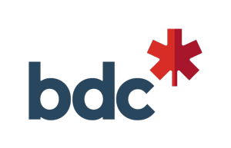

Founding Partners
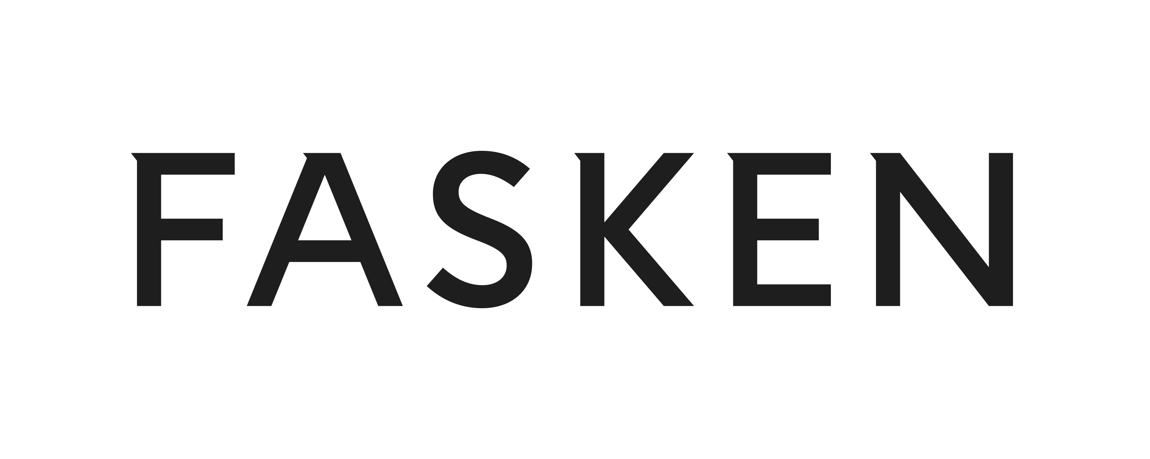

STANDARD NACO TERM SHEET for COMMON SHARES
[DATE]

A - MINIMUM REQUIRED TERMS

1. Issuer
[Name] (the "Corporation")

2. Business
The Corporation is a [city]-based [Insert brief description of business].

3. Financing
The Corporation is offering to issue [500,000] common shares of the Corporation (the "Common Shares") at $[1.00] per share (the "Purchase Price"), for a total of $[500,000] (the "Offering" or the "Financing") to a group of investors (the "Investors") at a pre-money valuation of $[2,200,000] and a post-money valuation of $[2,700,000], representing a fully diluted [18.52]% ownership in the Corporation post-money.
The Corporation’s share capital consists of Common Shares and options to purchase Common Shares ("Options"). As of the date of this term sheet, the Corporation has [2,000,000] Common Shares issued and outstanding, [200,000] Options are reserved under the Corporation’s Stock Option Plan (of which [150,000] have been granted).
There are no other securities of the Corporation outstanding. A capitalization table is attached as a schedule to this term sheet.

4. Closing Date
The Corporation will not close the Financing unless subscriptions for the aggregate minimum amount of $[500,000] are received from Investors.
The Financing will close no later than [Date], unless otherwise agreed by the parties to this term sheet.

5. Use of Proceeds
The Corporation will use the net proceeds of this Offering to complete the first release of its product, fund marketing activities and general corporate purposes.

6. Share Option Pool
The Corporation agrees to maintain a Share Option Plan providing for an option pool for the purchase of Common Shares that represents no more than [●]% of the fully diluted ownership of the Corporation [prior to][after] the completion of the Financing. All options issued under the Stock Option Plan are and will be subject to customary vesting provisions and will have an exercise strike price equivalent to the fair market value at the time of grant.
At closing, the Corporation will adopt a new [or amended] Share Option Plan that will govern the terms of all issued Options.

7. Decisions Requiring Approval
In addition to the requirements of corporate law, certain decisions of the Corporation will require approval by the Investors and other shareholders holding in the aggregate not less than [●]% of the issued and outstanding Common Shares as specified in the Shareholders Agreement (as defined below), including but not limited to the following:
(a) amending the articles or by-laws of the Corporation;
(b) issuing shares of the Corporation, or issuing securities exercisable or convertible into shares of the Corporation including share options (except pursuant to the approved Share Option Plan);
(c) declaring dividends or returning capital;
(d) redeeming or repurchasing any of the Corporation’s shares except upon the departure of a founder and or key employee;
(e) making loans or guaranteeing debts (except in the ordinary course of business);
(f) incurring debt if the Corporation’s aggregate indebtedness would be more than $[●];
(g) entering into a non-arm’s length transaction;
(h) entering into a sale of the Corporation or business combination transaction (including an amalgamation or plan of arrangement);
(i) voluntarily liquidating or dissolving the Corporation; and
(j) selling (or otherwise encumbering, disposing of or transferring) all or substantially all of the Corporation’s assets.
It may be appropriate to make changes to the above list depending on the situation. Consider whether a different approval threshold is appropriate – e.g. a majority-in-interest of the Investors versus all Shareholders.
Optional:
Investors may also be required to sign a voting trust where voting rights attached to the Common Shares purchased in this offering are transferred to a trustee for a specified period of time. A certain minimum number of investors may be agreed for this purpose.

8. Information
The Corporation will provide the Investors with the following:
(a) annual reviewed (or audited, if available) consolidated financial statements for the Corporation (including its income statement, balance sheet and cash flow statement) within 90 days of the Corporation’s financing year-end;
(b) management prepared (in accordance with GAAP) quarterly financial statements within 30 days of the end of each quarter and accountant prepared year-end financial statements (audited if required by law, but if waived Notice to Reader at a minimum) within 90 days of each fiscal year end;
(c) quarterly management reports within 30 days of the end of each quarter;
(d) a (board-approved) budget at the start of each fiscal year and any amendments thereto; and
(e) any other document reasonably requested by the Investors.
Optional:
(f) reports and updates that the Investors may reasonably ask for from time to time;
(g) access to a metrics platform (Hockeystick, Klipfolio, Google Docs) to share regularly updated data (if appropriate for business); and
(h) monthly updates.
If a voting trust is in place this information will be shared with the trustee who will disseminate among the Investors that are bound by the voting trust.

9. Pre-Emptive Rights
Each Investor will have a right to participate in a subsequent issuance of securities based on its pro rata ownership and with a right of oversubscription for the Investors of shares unsubscribed by the other Investors.
Include the "as converted" language if the Investors hold convertible securities. Note that some provinces have mandatory pre-emptive rights.

10. Right of First Refusal
Before any shares of the Corporation are sold by a shareholder [to a third party], those shares must first be offered on a pro-rata basis to all other shareholders based on such shareholders’ then-current holdings of Common Shares, subject to any restrictions in the Corporation’s articles.

11. Tag-Along (or Co-sale)
If a third party offer is made to purchase shares of the Corporation from a shareholder, then the third party offer must be made on a pro-rata basis to all shareholders (based on the shareholders’ then-current holdings of Common Shares).

12. Drag-Along Rights
If a bona fide offer is made by an arm’s length third party to acquire all of the shares of the Corporation, and the offer is accepted by shareholders holding at least [●]% of the then outstanding Common Shares [calculated on an as-converted basis for the Investors but otherwise] calculated on an undiluted basis, then the remaining shareholders of the Corporation will be obligated to sell their Common Shares pursuant to the third party offer.

13. Vesting
All Common Shares and share equivalents (including options) issued to founders and certain other key persons will be subject to customary vesting provisions that, to the extent they are not in place, will be incorporated in founder and key person employment agreements, the execution of which will be a condition precedent to closing.

14. Due Diligence
This term sheet does not provide a description of material information sufficient to describe the business and affairs of the Corporation. Investors may conduct such due diligence inquiries as they consider appropriate and the Corporation will provide access, subject to standard confidentiality provisions, to material documentation and information concerning the business, the Corporation and its respective management and third party advisors. Investors should, in conjunction with their professional advisers, make their own assessment of the merits and risks of any proposed investment in the Corporation.

15. Closing Conditions
Closing of the Financing will be subject to the following conditions, in addition to other customary closing conditions, including but not limited to:
(a) minimum Financing raised;
(b) completion of due diligence;
(c) execution of unanimous shareholders agreement by the Investors and all other shareholders (the "Shareholders Agreement");
(d) execution of employee and key person employment agreements which include vesting provisions (if applicable), NDAs and IP assignment (and may include key person insurance);
(e) appointment of a board of directors;
(f) conversion or payment of shareholder loans (or any other convertible instruments as the case may be);
(g) confirmation that the Corporation is a Canadian Controlled Private Corporation (CCPC);
(h) completion of all legal documentation and corporate minute book being up to date;
(i) establishment of new/amended Share Option Plan;
(j) tax credits have been applied for (depends on province); and
(k) no material adverse change.
A number of these are optional and will often depend on each situation, they will need to be negotiated in each investment case.

16. Subscriptions
The Offering is only available to accredited investors and friends, family or close business associates, in reliance on an exemption from the prospectus requirements in Canada as outlined in National Instrument 45-106.
The minimum subscription is $[25,000] per Investor. Individual subscriptions may be scaled back in case of an oversubscription.

17. Documentation
At Closing, the following agreements will be entered into:
(a) Subscription agreements, which will include customary representations and warranties from the Corporation and the Investor , with a survival period of [two] years.
(b) Shareholders Agreement or joinder to the existing Shareholders Agreement, subject to Investor approval.
(c) Share Option Plan, subject to Investor Approval.

Optional
(d) Employment agreements as contemplated above.

18. Cost and Legal Counsel
The Corporation agrees to bear its own costs and cover the Investor’s legal costs up to a maximum of $[●] in the aggregate.
or
Each party to this term sheet agrees to bear its own legal costs.

19. Confidentiality
The Corporation and the Investors will refrain from publicity and not disclose any information concerning this term sheet without the written approval of the other party, except as required by law and provided that the parties may disclose information to their accountants, legal counsel and other professional advisors.

20. Expiry
This term sheet expires at [Time] on [Date].

21. Binding Nature
This term sheet is non-binding, except for Sections 18, 19, 20, 21 and 22, which are intended to be binding and which will survive termination of this term sheet.
22. Governing Law
This term sheet is governed by the laws of [Province] and applicable federal laws of Canada.

B - EXTENDED TERMS

B1. Investor (s)
[Name] and other investors acceptable to the Corporation (collectively the "Investors" and each an "Investor"). The Investors will appoint a single investor to lead the Financing with the Corporation (the "Lead Investor"). The Lead Investor (in consultation with the other Investors) shall finalize the terms of the Financing, as described herein.

B2. Price Protection Rights
Also Known As: Anti-Dilution
If the Corporation issues additional securities at a purchase or conversion price less than the Purchase Price (subject to customary exclusions), the conversion price of the Preferred Shares will be subject to a [full ratchet / weighted average] adjustment to reduce the dilution of the Investors based on the price or conversion price at which the new securities are issued.
There are two common ways to adjust the share allocation in a scenario like this: (1) weighted average (broad-based or narrow-based) and (2) full ratchet. See notes.

B3. Board of Directors
The Corporation’s board of directors currently consists of [two] directors. Upon completion of the Financing, the board of directors will be increased in size to [three] directors, and the Investors will have the right to appoint [one] of the [three] directors. This will be documented in the Shareholders Agreement.
or
The Investors will have the right to appoint an observer.

B4. Exclusivity
From the date of acceptance of this term sheet until the earliest of (a) the Closing Date (b) the formal termination of negotiation by both the Investors and the Corporation, the Corporation will not directly or indirectly solicit, initiate or participate in any discussions or negotiations with, or encourage or respond to any inquiries or proposals by any persons, Corporation or group other than the Investors, concerning any financing or sale of the Corporation without prior approval of the Investors.
Option: add a time limit to this period, e.g. 90 days.

B5. Tax Credits
Depending on jurisdiction, and whether the Corporation qualifies, the Corporation would insert appropriate language here that outlines its commitment to obtain the relevant tax credits for each eligible investor participating in the Offering.
Example (BC): The Corporation is an Eligible Business Corporation under the terms of the British Columbia Small Business Venture Capital Act and will apply for a 30% tax investment credit for BC-based investors for investment made up to March 1, 2018.

[Signature Page Follows]

Yours truly,

[INVESTOR]
Per:
Name:
Title:

ACCEPTED AND AGREED _______________________, 20____.

[CORPORATION]
Per:
Name:
Title:

